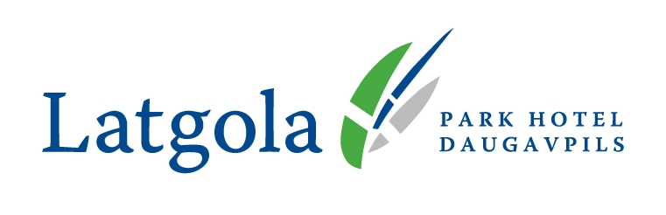
„Park Hotel Latgola”
Ģimnāzijas 46
Daugavpils, LV5400
www.hotellatgola.lv
Phone +371 65404900
E-mail: reception@hotellatgola.lv

“Draugu dejas 2023” Participants

SPECIAL OFFER FOR
ACCOMODATION in PARK HOTEL LATGOLA
14. - 16.10.2023.

Standard single room – 40,00Eur
Standard double/twin room – 45,00 Eur
Business class trpl room – 60,00 Eur

Business class single room – 50,00 Eur
Business class double/twin room – 60,00 Eur
Breakfast is included in the offer price!

For more information and for reservation, please contact our Reception department! For applying discount, please mention, that you are going to the “Draugu dejas 2023”!
Phone: +371 65404900 or e-mail: reservation@hotellatgola.lv !

OUR ADVANTAGES:
Panorama View / City centre / Comfort & Taste / High quality & Service /
Friendly & welcoming staff

Best regards,
Andrejs Nariškins
“Park Hotel Latgola”
General Manager
Phone: +371 65404900
E-mail: manager@hotellatgola.lv

02.10.2023.

