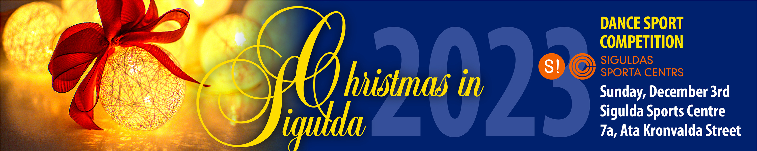
* SOLO, born 2017 and younger, WCh  * SOLO, born 2016 and younger, WCh  * SOLO, born 2015 and younger, WCH lvl 1 to 2  * SOLO, born 2015 and younger, WCHJ lvl 1 to 2 | 1 part  Registration  9:30 – 10:15  Beginning 11:00 | * SOLO, born 2014 and younger, WChJ lvl 1 to 2  * SOLO, born 2012 and younger, WChJ lvl 1 to 2  * SOLO, Ch CUP, lvl 1 to 2
* SOLO, born 2015 and younger, WQChJ  * SOLO, born 2013 and younger, WQChJ  * SOLO, born 2011 and younger, WQChJ  * SOLO, WVQChRJ | 2 part  Registration  10:30 – 11:15  Beginning 12:00 | * SOLO, W Cup  * SOLO, Ch Cup  * SOLO, LA Cup CH J
* Beginners, born 2019 and younger, WCh lvl 1  * Beginners, born 2017 and younger, WCh lvl 1  * Beginners, born 2015 and younger, WCh lvl 1 to 2 | 3 part  12:15 – 13:00  Beginning 13:45 | *Beginners, born 2011 and younger, WQCHJ lvl 2 to 3  * Juvenile I E4  * Juvenile II E4
* Beginners, born 2016 and younger, WChJ lvl 1 to 2  * Beginners, born 2016 and younger, WQChJ lvl 1 to 2 * Beginners, born 2014 and younger, WCh lvl 1  * Beginners, born 2014 and younger, WChJ lvl 1 to 2  * Beginners, born 2014 and younger, WQChJ lvl 1 to 2 | 4 part  Registration  13:30 – 14:15  Beginning 15:00 | * Beginners, born 2013 and younger, WQCHJ lvl 2 to 3  * Beginners, J Cup  * Beginners, Ch Cup  * Juvenile I + Juvenile II E4  * Junior I + II E4
* Juvenile I + II E6  * Junior II + Youth CB ST | 5 part  Registration  15:30 – 16:15  Beginning 17:00 | * Junior I E4  * Junior II + Youth CB LA
* Junior I +II E6  * Junior II + Youth D ST  * Youth + Adults CBA ST  * Senior III + IV ST | 6 part  Registration  15:45 – 16:15  Beginning 17:15 | * Junior II + Youth D LA  * Youth + Adults CBA LA

The competition schedule will be planned so that couples can participate in both ST and LA competitions in one session,
where applicable. The final timetable will be published one day after the closing of the registration.
Heel protectors are mandatory for ladies’ shoes.  The dancers, their parents, and dance club representatives are responsible for the participants' health  Café will be available in the venue. | Cups and diplomas to all participants of Beginners and Solo groups.  Cups to all participants of one dance competitions.  Cups and diplomas to 1st-3rd places.  Medals and diplomas to 4th-5th places. | Registration on www.lsdf.lv is mandatory and will be open until end  of 30 November.  Participation fee EUR 10 per program  Entrance fee EUR 10

